**EXPERIMENT 3 B**

**NAME: Shivam Pawar UID: 2019230068**

**NAME: Vishal Salvi UID: 2019230069**

**NAME: Shreyas Patel UID: 2018130043**

**CLASS: TE COMPS BATCH: C**

**Aim**: Creating basic web application by using framework.

**Theory:**

**Databases**

**Django officially supports the following databases:**

* [PostgreSQL](https://docs.djangoproject.com/en/3.1/ref/databases/#postgresql-notes)
* [MariaDB](https://docs.djangoproject.com/en/3.1/ref/databases/#mariadb-notes)
* [MySQL](https://docs.djangoproject.com/en/3.1/ref/databases/#mysql-notes)
* [Oracle](https://docs.djangoproject.com/en/3.1/ref/databases/#oracle-notes)
* [SQLite](https://docs.djangoproject.com/en/3.1/ref/databases/#sqlite-notes)

There are also a number of [database backends provided by third parties](https://docs.djangoproject.com/en/3.1/ref/databases/#third-party-notes).

Django attempts to support as many features as possible on all database backends. However, not all database backends are alike, and we’ve had to make design decisions on which features to support and which assumptions we can make safely.

### **Optimizing PostgreSQL’s configuration**

Django needs the following parameters for its database connections:

* **client_encoding**: **'UTF8'**,
* **default_transaction_isolation**: **'read committed'** by default, or the value set in the connection options (see below),
* **timezone**:
  + when [**USE_TZ**](https://docs.djangoproject.com/en/3.1/ref/settings/#std:setting-USE_TZ) is **True**, **'UTC'** by default, or the [**TIME_ZONE**](https://docs.djangoproject.com/en/3.1/ref/settings/#std:setting-DATABASE-TIME_ZONE) value set for the connection,
  + when [**USE_TZ**](https://docs.djangoproject.com/en/3.1/ref/settings/#std:setting-USE_TZ) is **False**, the value of the global [**TIME_ZONE**](https://docs.djangoproject.com/en/3.1/ref/settings/#std:setting-TIME_ZONE) setting.

If these parameters already have the correct values, Django won’t set them for every new connection, which improves performance slightly. You can configure them directly in **postgresql.conf** or more conveniently per database user with [ALTER ROLE](https://www.postgresql.org/docs/current/sql-alterrole.html).

Django will work just fine without this optimization, but each new connection will do some additional queries to set these parameters.

## **MySQL**

### Version support

Django supports MySQL 5.6 and higher.

Django’s **inspectdb** feature uses the **information_schema** database, which contains detailed data on all database schemas.

Django expects the database to support Unicode (UTF-8 encoding) and delegates to it the task of enforcing transactions and referential integrity. It is important to be aware of the fact that the two latter ones aren’t actually enforced by MySQL when using the MyISAM storage engine, see the next section.

### **Storage engines**

MySQL has several [storage engines](https://dev.mysql.com/doc/refman/en/storage-engines.html). You can change the default storage engine in the server configuration.

MySQL’s default storage engine is [InnoDB](https://dev.mysql.com/doc/refman/en/innodb-storage-engine.html). This engine is fully transactional and supports foreign key references. It’s the recommended choice. However, the InnoDB autoincrement counter is lost on a MySQL restart because it does not remember the **AUTO_INCREMENT** value, instead recreating it as “max(id)+1”. This may result in an inadvertent reuse of [**AutoField**](https://docs.djangoproject.com/en/3.1/ref/models/fields/#django.db.models.AutoField) values.

The main drawbacks of [MyISAM](https://dev.mysql.com/doc/refman/en/myisam-storage-engine.html) are that it doesn’t support transactions or enforce foreign-key constraints.

### **MySQL DB API Drivers**

MySQL has a couple drivers that implement the Python Database API described in [**PEP 249**](https://www.python.org/dev/peps/pep-0249):

* [mysqlclient](https://pypi.org/project/mysqlclient/) is a native driver. It’s **the recommended choice**.
* [MySQL Connector/Python](https://dev.mysql.com/downloads/connector/python) is a pure Python driver from Oracle that does not require the MySQL client library or any Python modules outside the standard library.

These drivers are thread-safe and provide connection pooling.

In addition to a DB API driver, Django needs an adapter to access the database drivers from its ORM. Django provides an adapter for mysqlclient while MySQL Connector/Python includes [its own](https://dev.mysql.com/doc/connector-python/en/connector-python-django-backend.html).

#### mysqlclient

Django requires [mysqlclient](https://pypi.org/project/mysqlclient/) 1.4.0 or later.

#### MySQL Connector/Python

MySQL Connector/Python is available from the [download page](https://dev.mysql.com/downloads/connector/python/). The Django adapter is available in versions 1.1.X and later. It may not support the most recent releases of Django.

### Time zone definitions

If you plan on using Django’s [timezone support](https://docs.djangoproject.com/en/3.1/topics/i18n/timezones/), use [mysql_tzinfo_to_sql](https://dev.mysql.com/doc/refman/en/mysql-tzinfo-to-sql.html) to load time zone tables into the MySQL database. This needs to be done just once for your MySQL server, not per database.

### Creating your database

You can [create your database](https://dev.mysql.com/doc/refman/en/create-database.html) using the command-line tools and this SQL:

CREATE DATABASE <dbname> CHARACTER SET utf8;

This ensures all tables and columns will use UTF-8 by default.

#### Collation settings

The collation setting for a column controls the order in which data is sorted as well as what strings compare as equal. It can be set on a database-wide level and also per-table and per-column. This is [documented thoroughly](https://dev.mysql.com/doc/refman/en/charset.html) in the MySQL documentation. In all cases, you set the collation by directly manipulating the database tables; Django doesn’t provide a way to set this on the model definition.

By default, with a UTF-8 database, MySQL will use the **utf8_general_ci** collation. This results in all string equality comparisons being done in a case-insensitive manner. That is, **"Fred"** and **"freD"** are considered equal at the database level. If you have a unique constraint on a field, it would be illegal to try to insert both **"aa"** and **"AA"** into the same column, since they compare as equal (and, hence, non-unique) with the default collation. If you want case-sensitive comparisons on a particular column or table, change the column or table to use the **utf8_bin** collation.

Please note that according to [MySQL Unicode Character Sets](https://dev.mysql.com/doc/refman/en/charset-unicode-sets.html), comparisons for the **utf8_general_ci** collation are faster, but slightly less correct, than comparisons for **utf8_unicode_ci**. If this is acceptable for your application, you should use **utf8_general_ci** because it is faster. If this is not acceptable (for example, if you require German dictionary order), use **utf8_unicode_ci** because it is more accurate.

# Customizing authentication in Django

The authentication that comes with Django is good enough for most common cases, but you may have needs not met by the out-of-the-box defaults. Customizing authentication in your projects requires understanding what points of the provided system are extensible or replaceable. This document provides details about how the auth system can be customized.

[Authentication backends](https://docs.djangoproject.com/en/3.1/topics/auth/customizing/#authentication-backends) provide an extensible system for when a username and password stored with the user model need to be authenticated against a different service than Django’s default.

You can give your models [custom permissions](https://docs.djangoproject.com/en/3.1/topics/auth/customizing/#custom-permissions) that can be checked through Django’s authorization system.

You can [extend](https://docs.djangoproject.com/en/3.1/topics/auth/customizing/#extending-user) the default **User** model, or [substitute](https://docs.djangoproject.com/en/3.1/topics/auth/customizing/#auth-custom-user) a completely customized model.

## **Other authentication sources**

There may be times you have the need to hook into another authentication source – that is, another source of usernames and passwords or authentication methods.

For example, your company may already have an LDAP setup that stores a username and password for every employee. It’d be a hassle for both the network administrator and the users themselves if users had separate accounts in LDAP and the Django-based applications.

So, to handle situations like this, the Django authentication system lets you plug in other authentication sources. You can override Django’s default database-based scheme, or you can use the default system in tandem with other systems.

See the [authentication backend reference](https://docs.djangoproject.com/en/3.1/ref/contrib/auth/#authentication-backends-reference) for information on the authentication backends included with Django.

### Specifying authentication backends:

Behind the scenes, Django maintains a list of “authentication backends” that it checks for authentication. When somebody calls [**django.contrib.auth.authenticate()**](https://docs.djangoproject.com/en/3.1/topics/auth/default/#django.contrib.auth.authenticate) – as described in [How to log a user in](https://docs.djangoproject.com/en/3.1/topics/auth/default/#how-to-log-a-user-in) – Django tries authenticating across all of its authentication backends. If the first authentication method fails, Django tries the second one, and so on, until all backends have been attempted.

The list of authentication backends to use is specified in the [**AUTHENTICATION_BACKENDS**](https://docs.djangoproject.com/en/3.1/ref/settings/#std:setting-AUTHENTICATION_BACKENDS) setting. This should be a list of Python path names that point to Python classes that know how to authenticate. These classes can be anywhere on your Python path.

By default, [**AUTHENTICATION_BACKENDS**](https://docs.djangoproject.com/en/3.1/ref/settings/#std:setting-AUTHENTICATION_BACKENDS) is set to:

['django.contrib.auth.backends.ModelBackend']

That’s the basic authentication backend that checks the Django users database and queries the built-in permissions. It does not provide protection against brute force attacks via any rate limiting mechanism. You may either implement your own rate limiting mechanism in a custom auth backend, or use the mechanisms provided by most Web servers.

The order of [**AUTHENTICATION_BACKENDS**](https://docs.djangoproject.com/en/3.1/ref/settings/#std:setting-AUTHENTICATION_BACKENDS) matters, so if the same username and password is valid in multiple backends, Django will stop processing at the first positive match.

**Screenshot:**

**Run Server**

This is the home page of Mumbai Tour and guide management.



Here user can see whatever activities, tours as well as hotel booking features in system

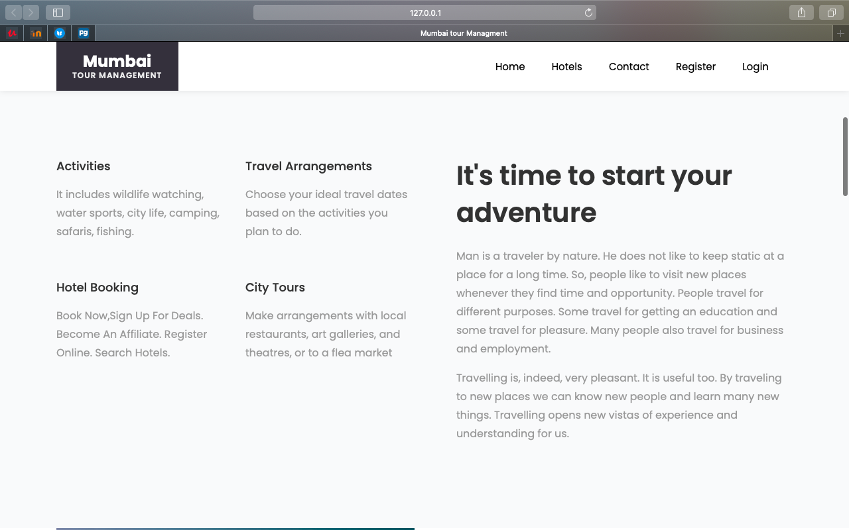

User can see count of happy tourist and place explored by tourist

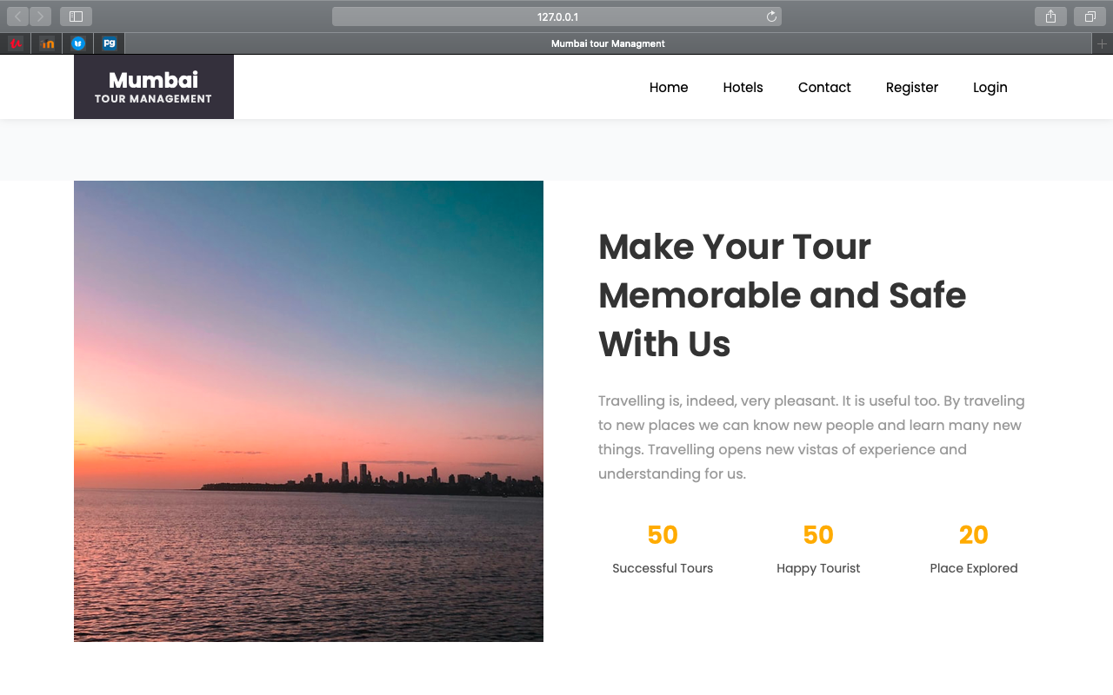

After that user can view tour destination

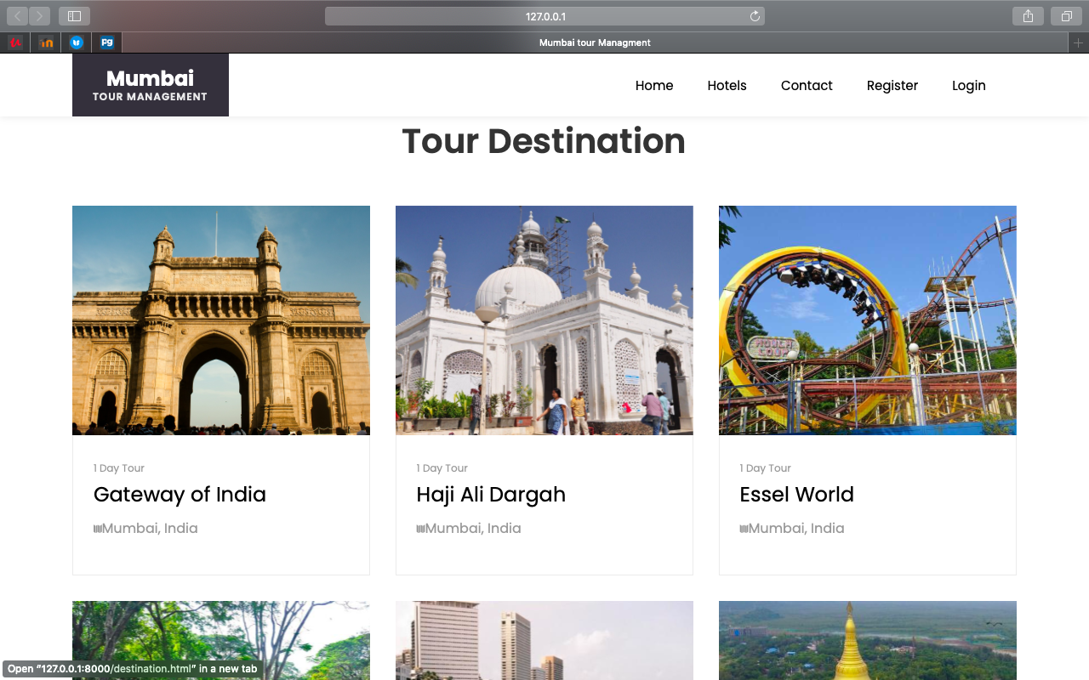

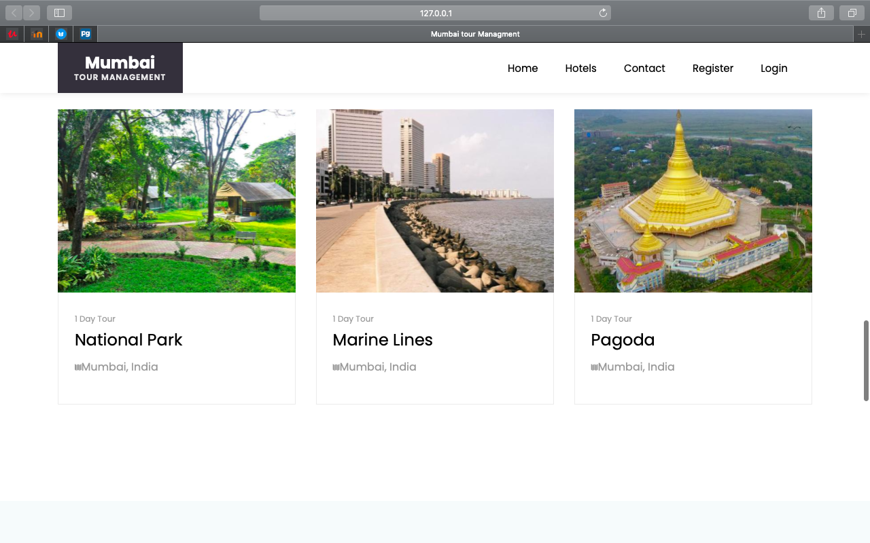

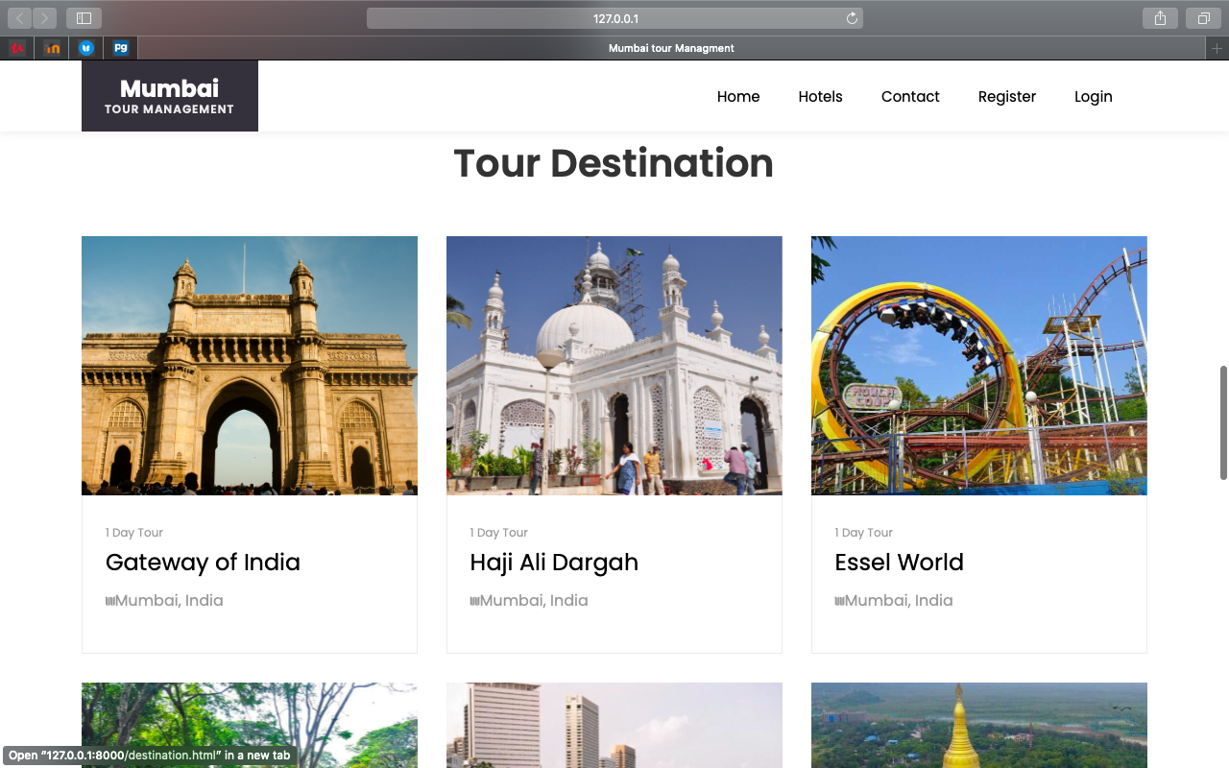

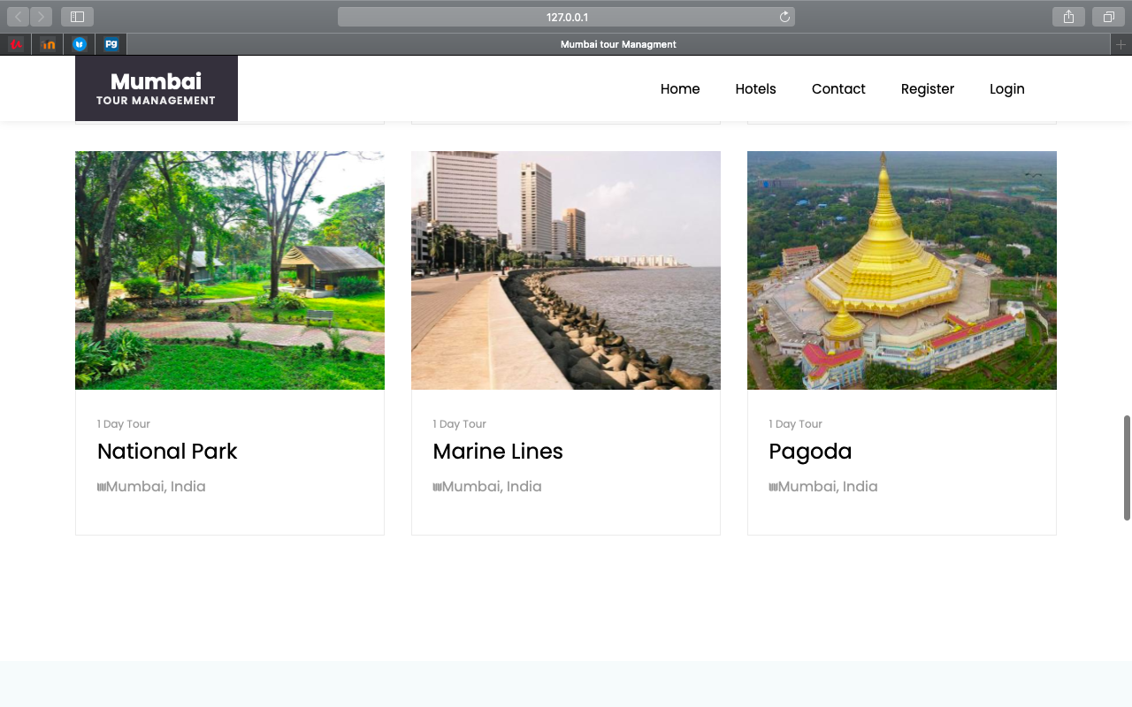

Then user get tourist feedback

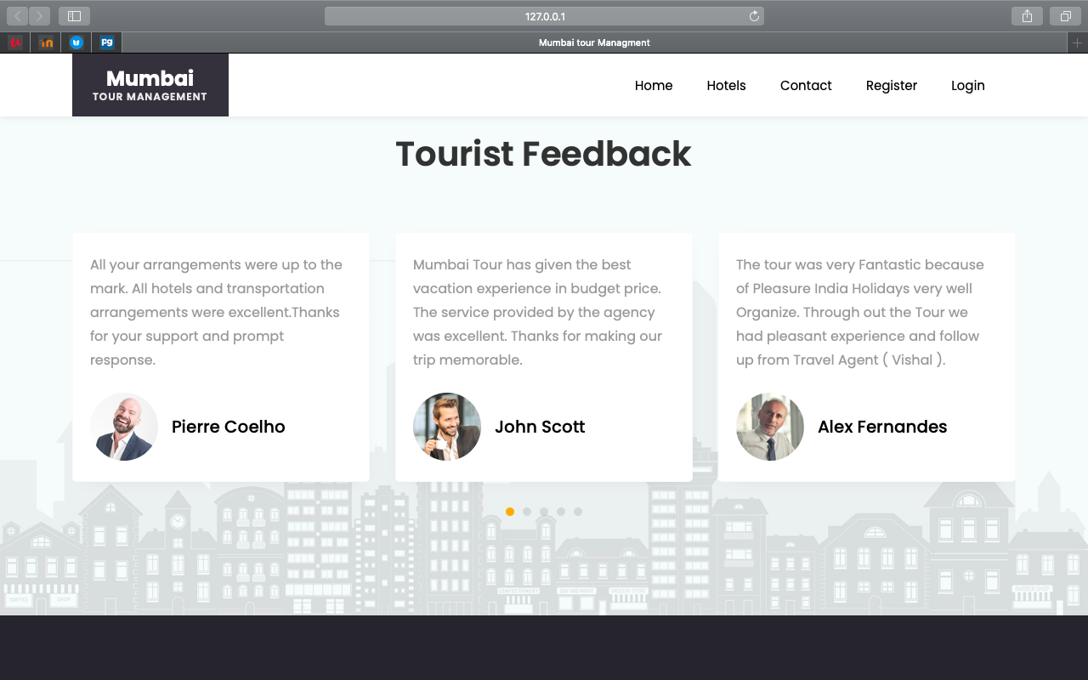

This is Hotel Reception view



Here, User can see Recommended Hotels which are near by tour location

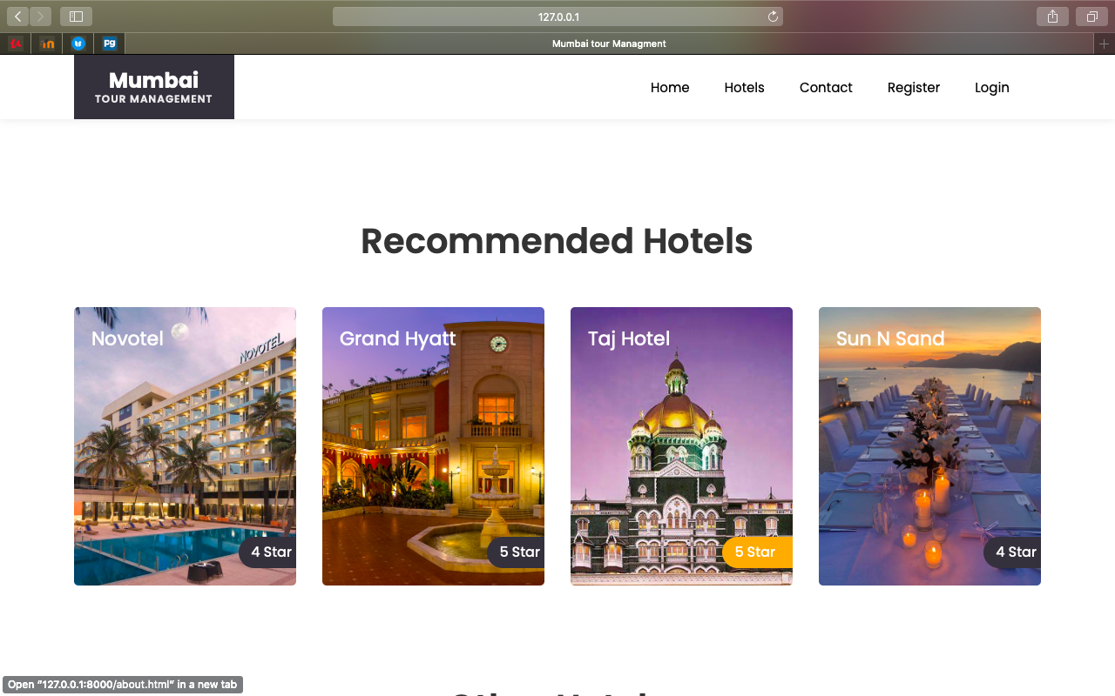

Other Hotels

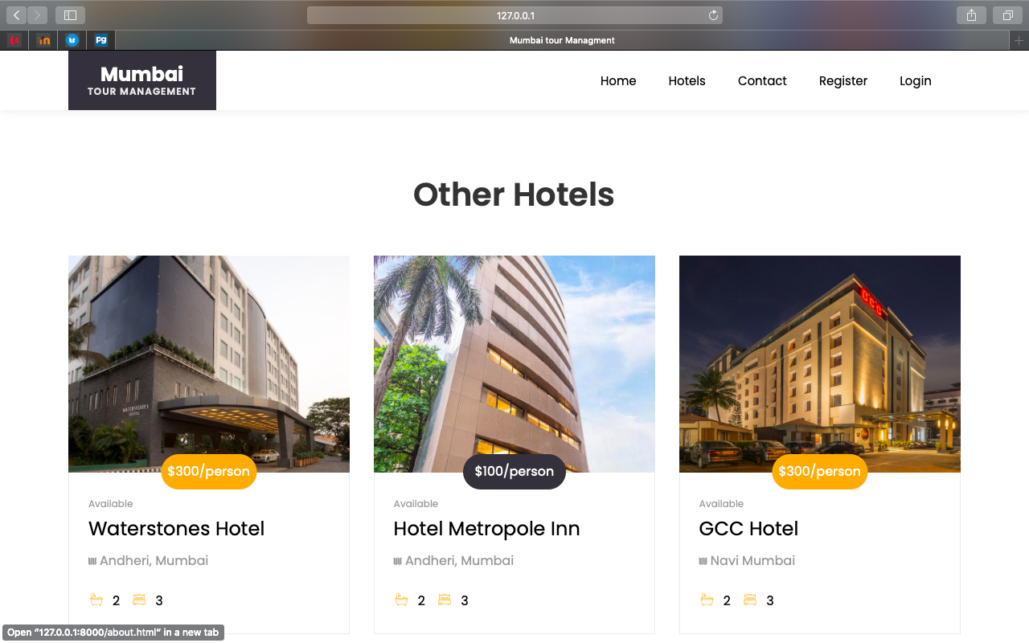

User can view different hotels as well as details about hotel and hotel rating also

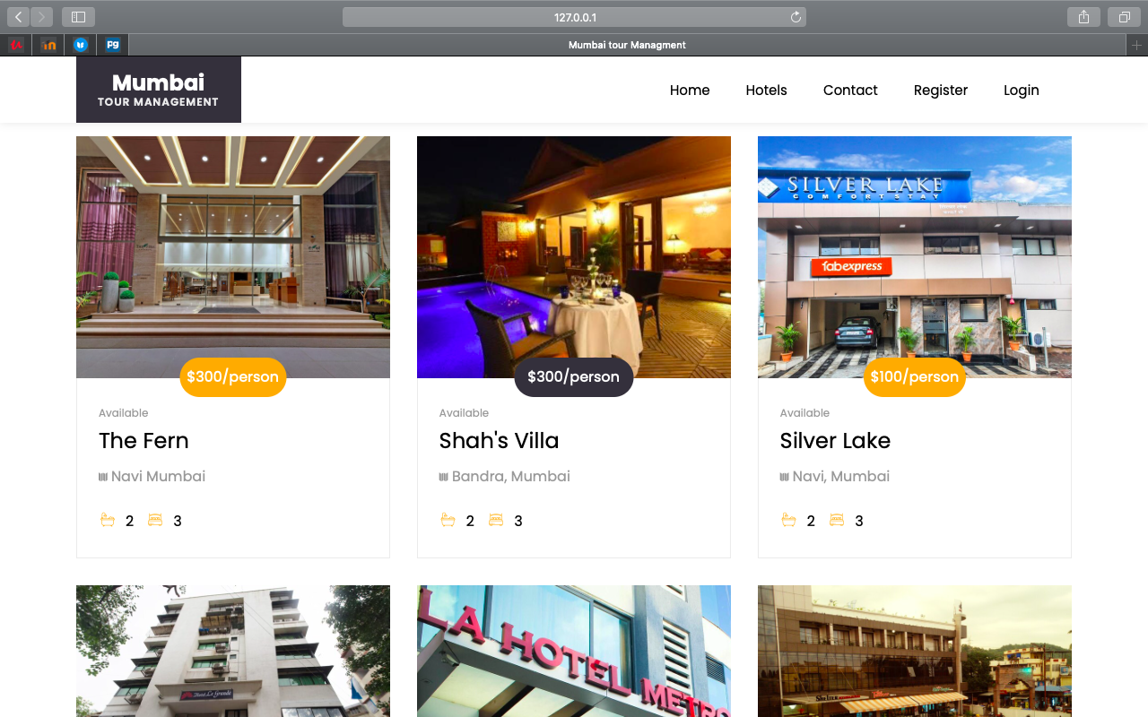

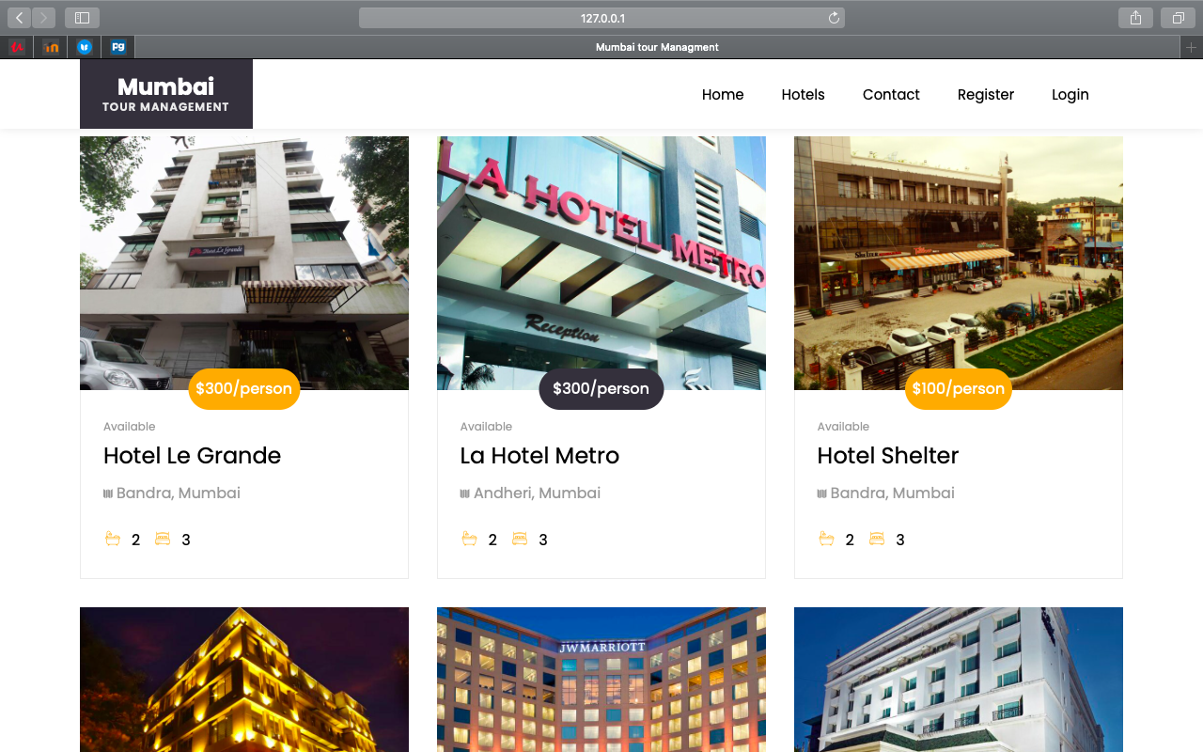

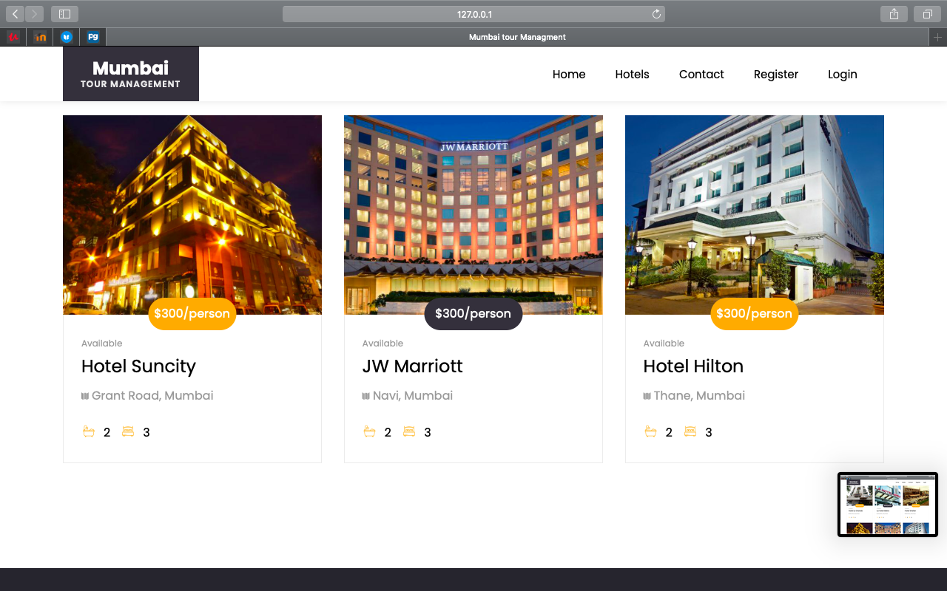

Then, User can view of room in hotel.

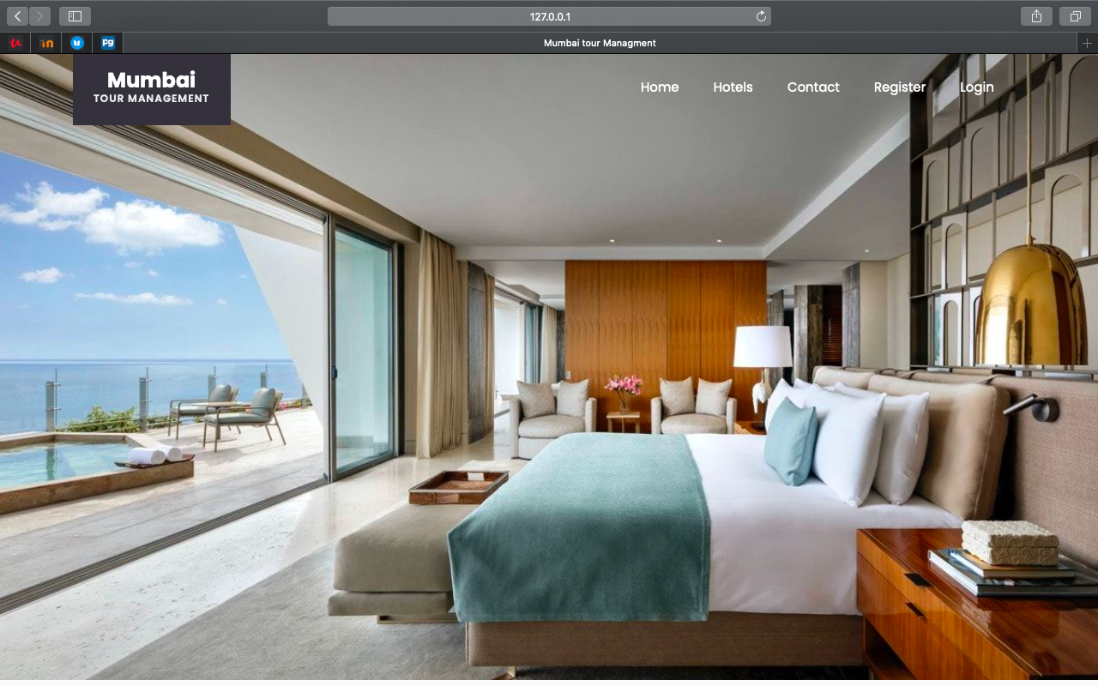

After that can get features of hotel like Fitness centre, Tennis courts, Cafe etc.

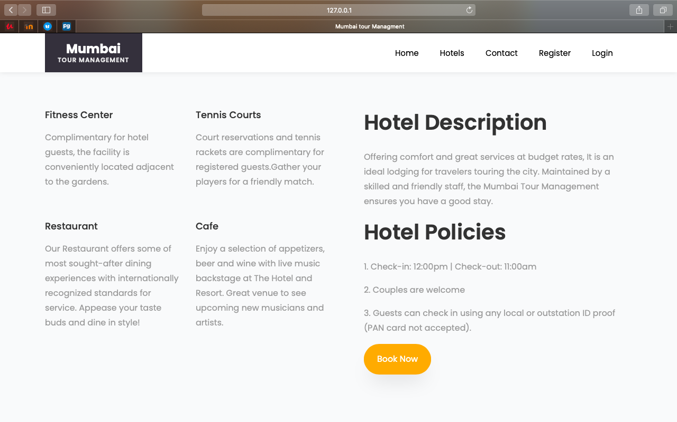

Then user get tourist feedback

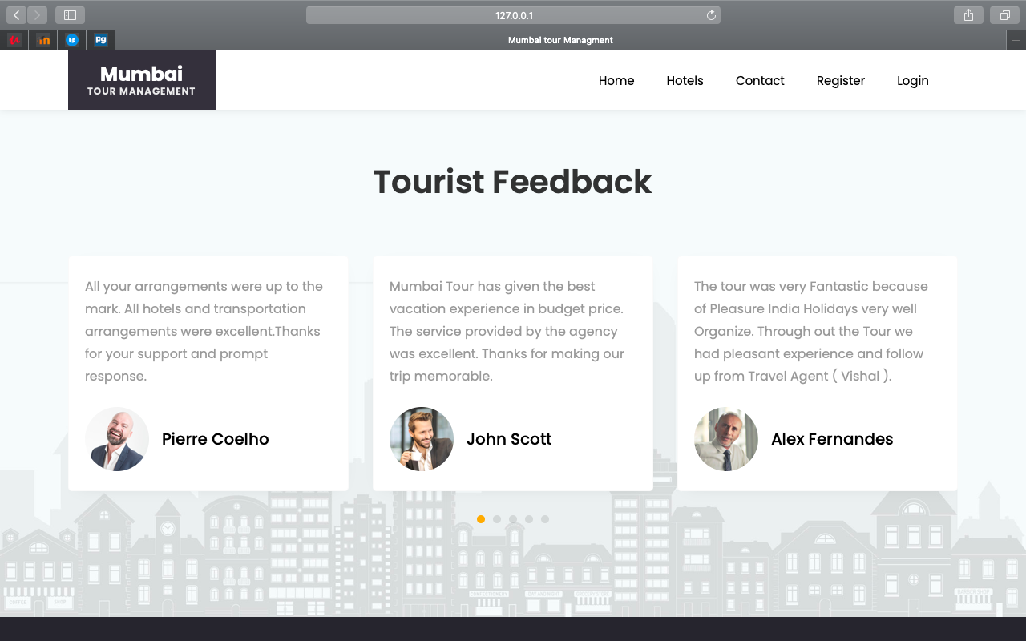

Next is contact page

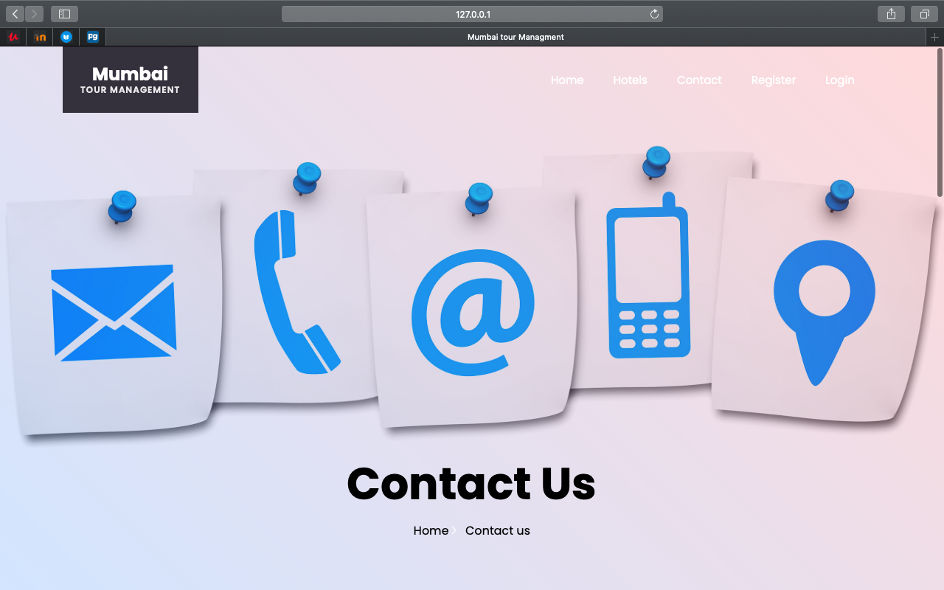

User can send message to hotel as well as can add review.

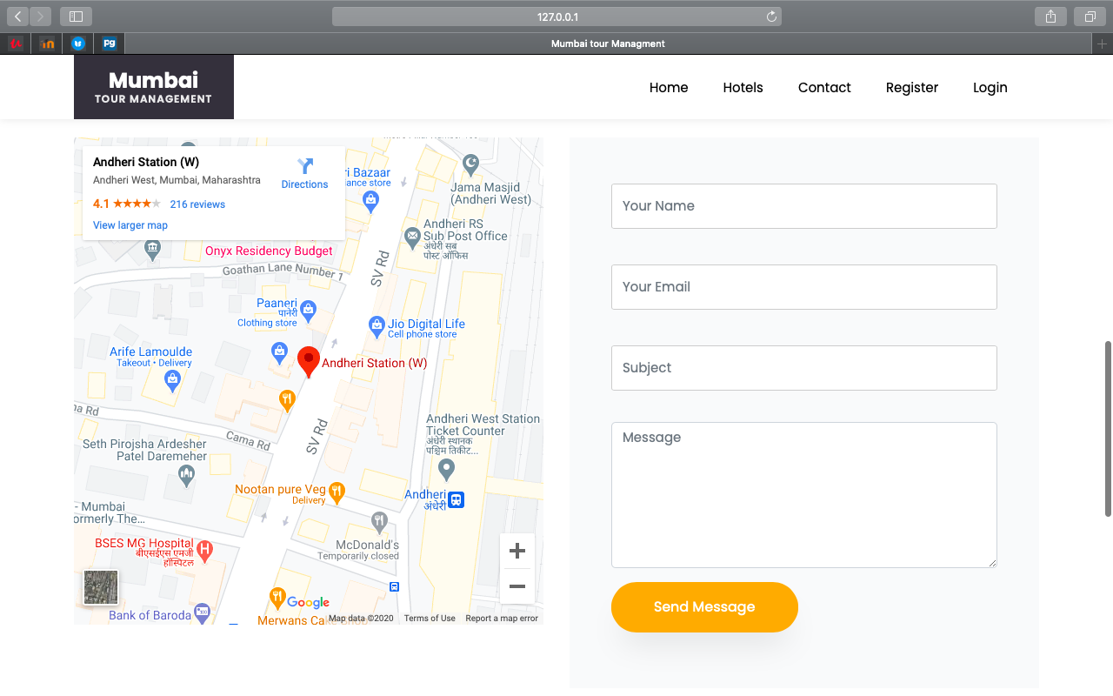

For booking hotel user need to log in system .If user not register in the system then he/she need to register in the application .



For registration user need to fill the details like First name, Last name User Name, Email as well as Password etc.

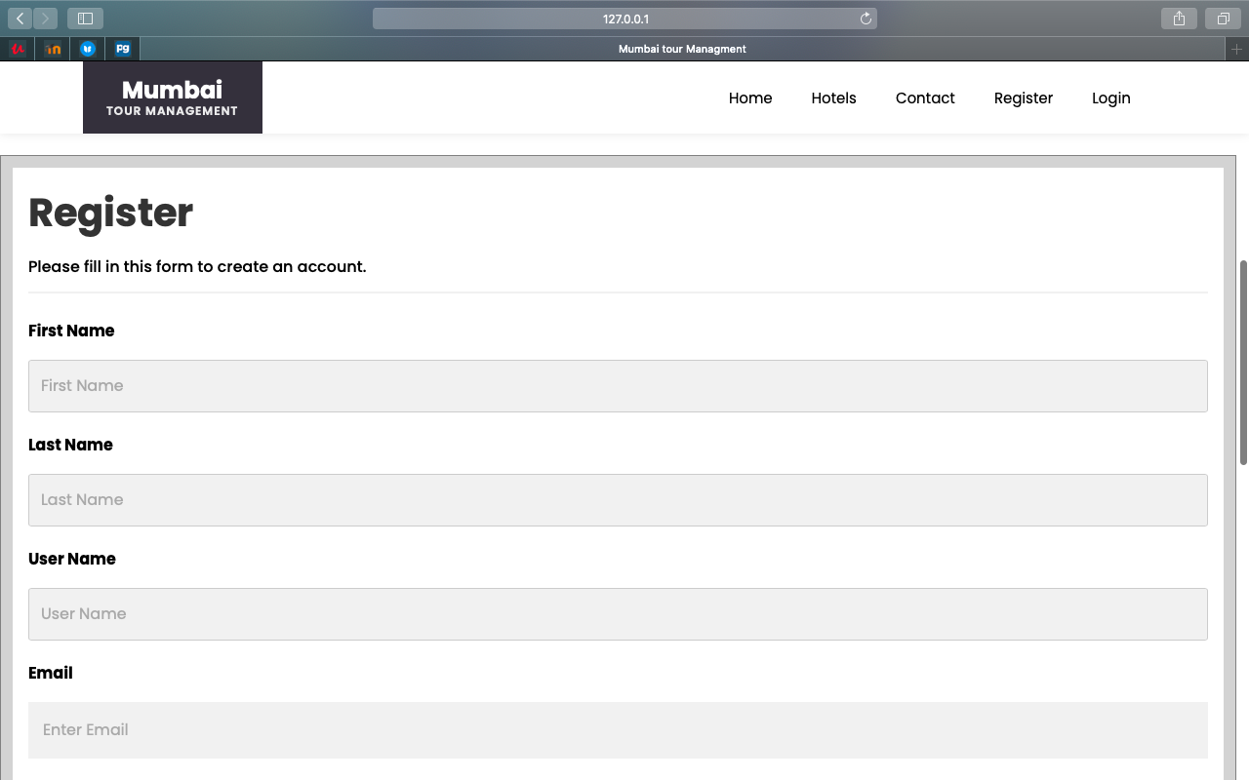

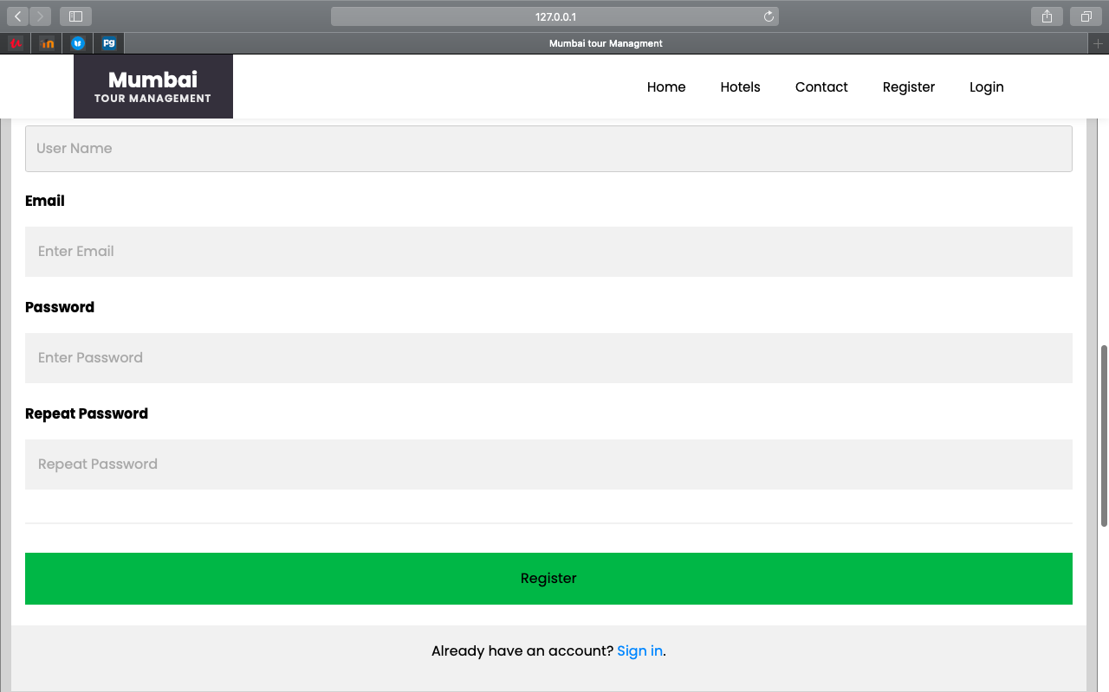

If username is same in database or user can’t add already register username.

If user add register username then error message prompt on screen that is Username already taken

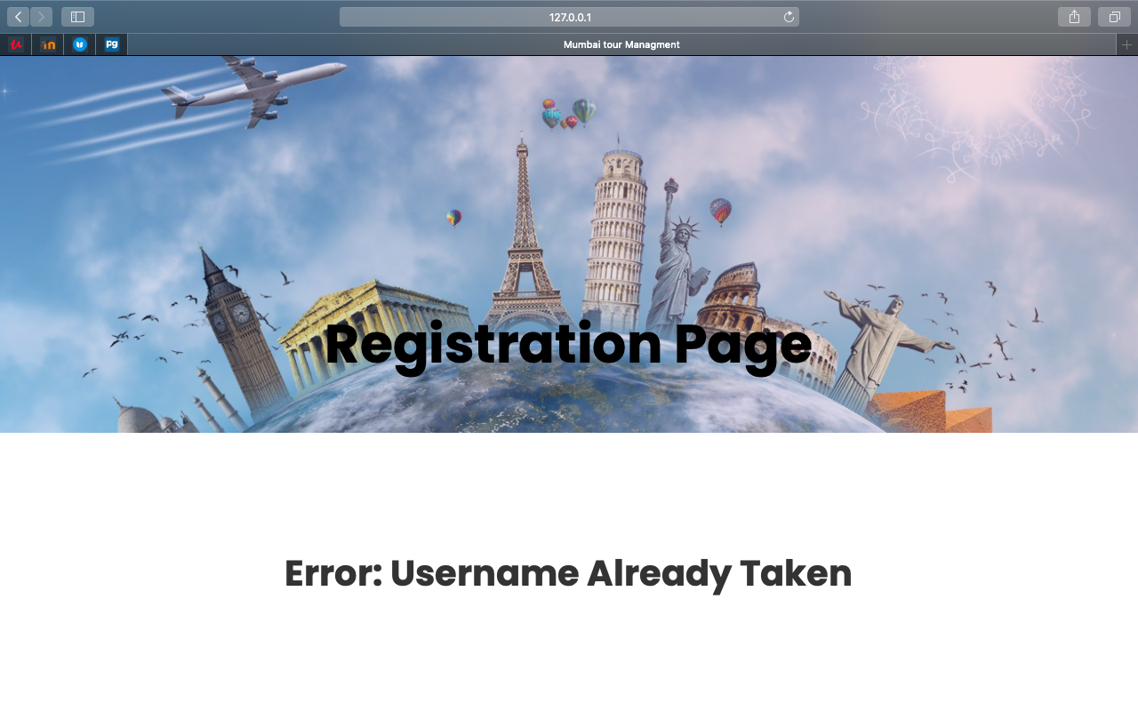

Once user register in system after that he/she can log in system for booking hotel.

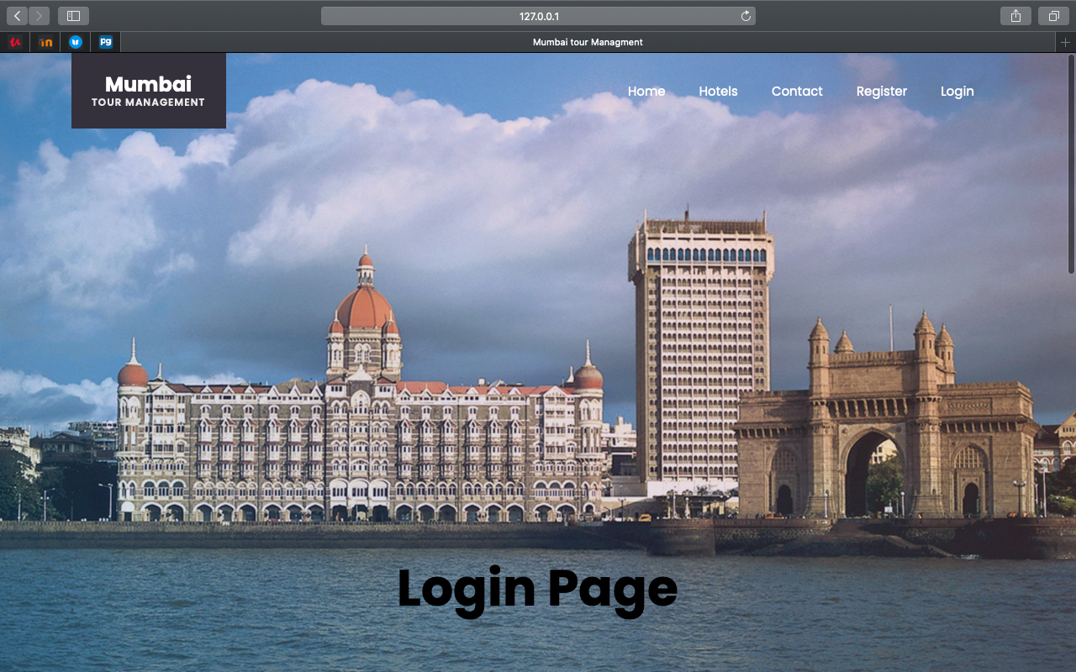

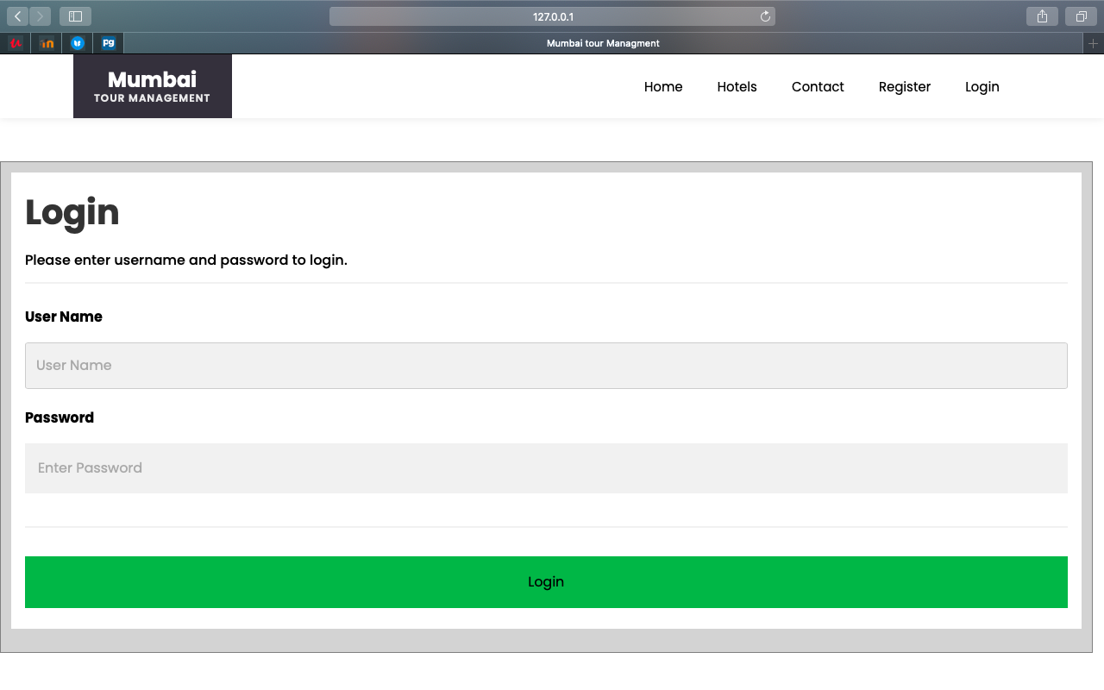

If username and password wrong then error message will display that is Invalid credentials

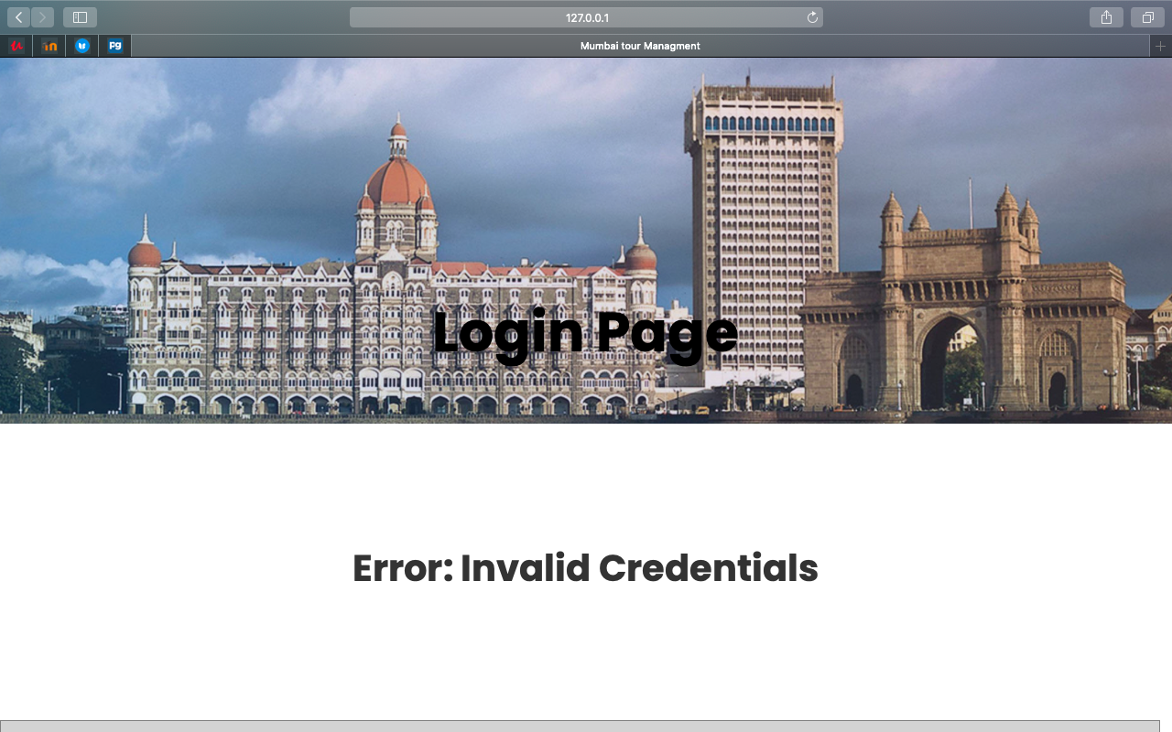

Click on Book Now Button for booking hotel.

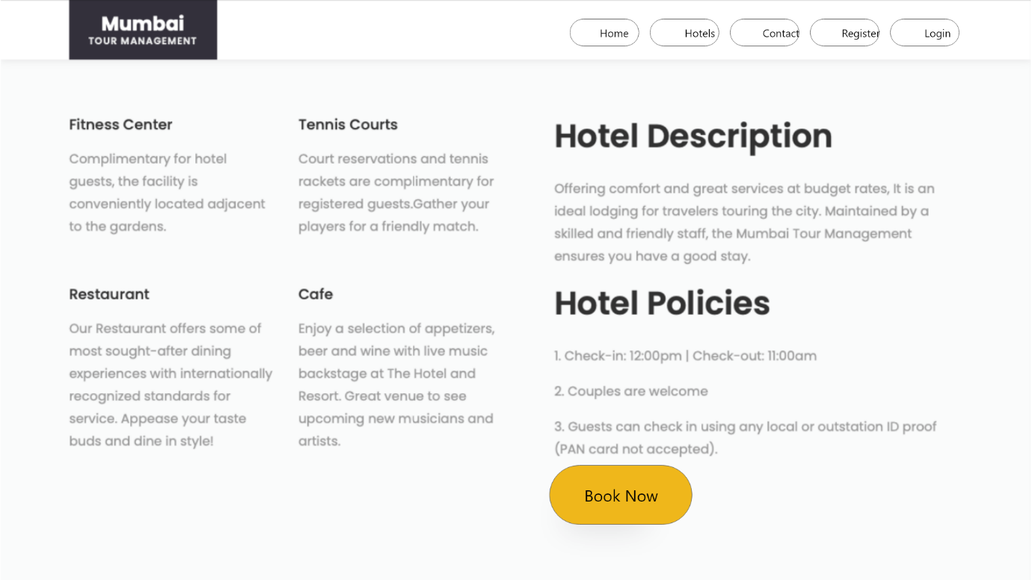

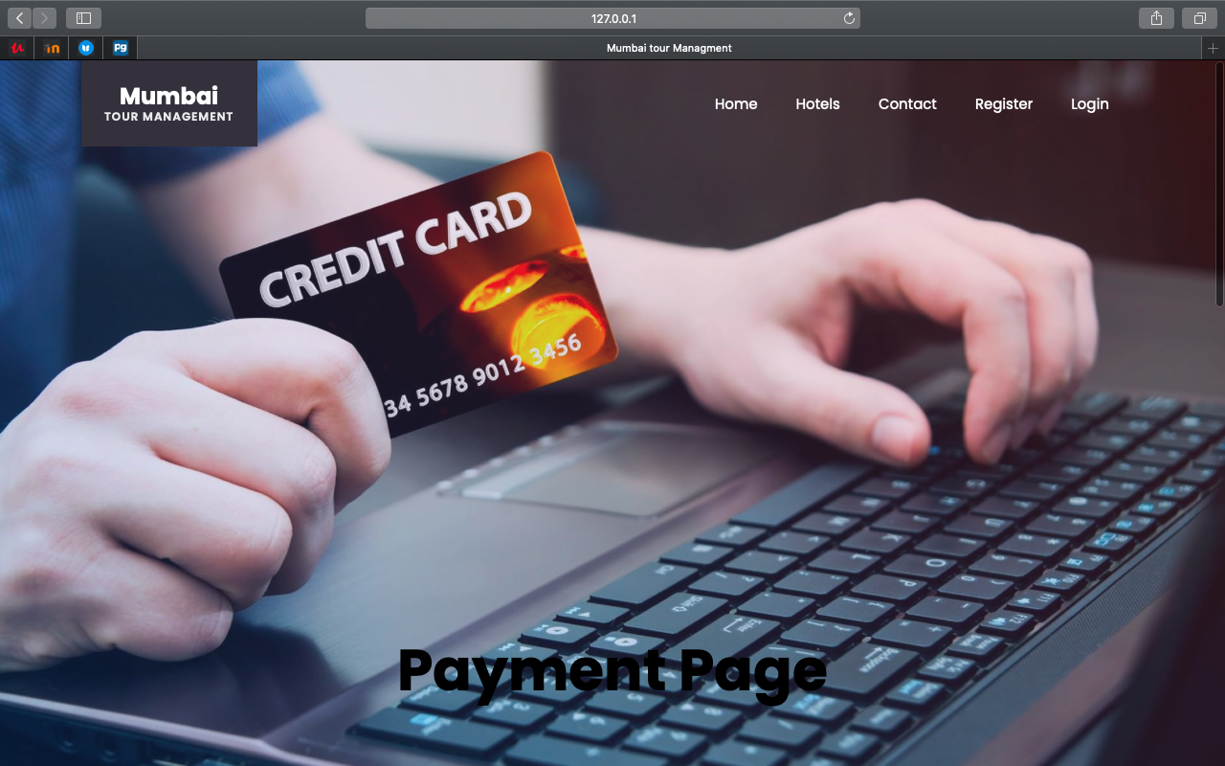

After that user need to add details about payment like city, state, zip, Name on card , Credit card number, Exp month, Exp year and CVV etc.

When user click on make payment button if all required details are correct then payment will be successful.

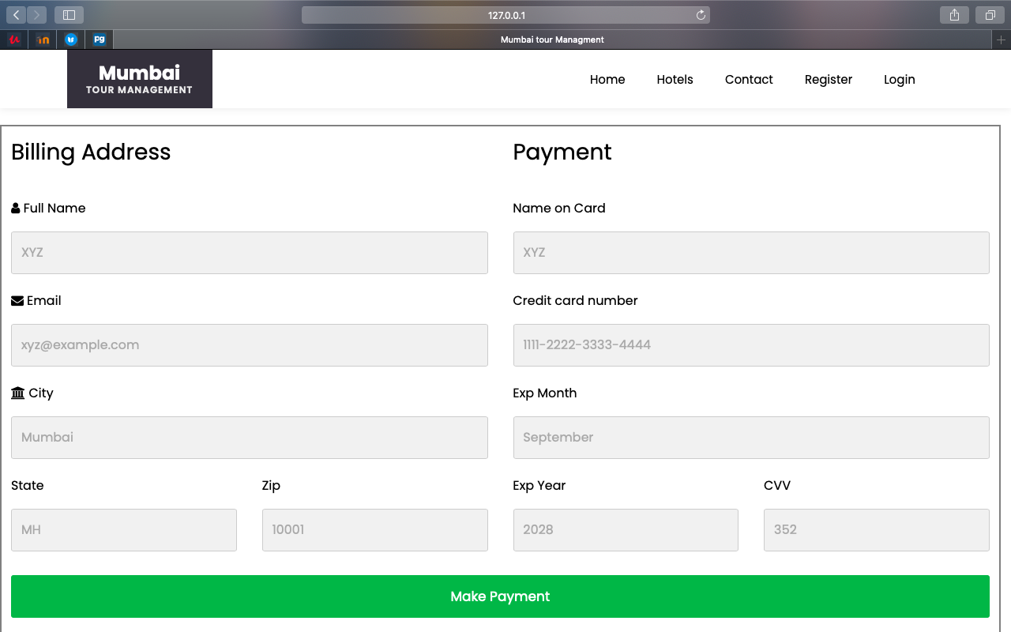

Contact Info

User can call to Hotel to ask some info regarding hotel.

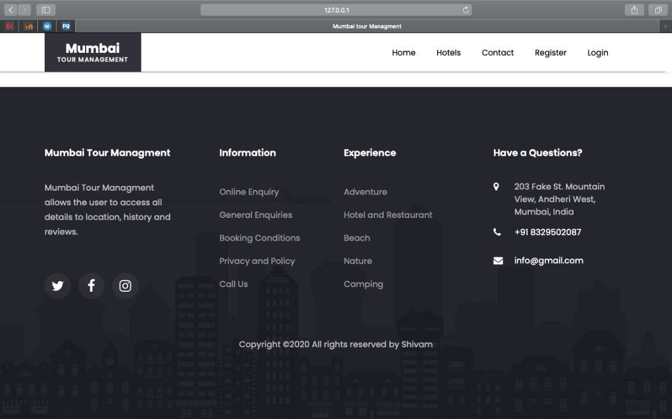

**Database:**

We are using [PostgreSQL](https://docs.djangoproject.com/en/3.1/ref/databases/#postgresql-notes) Database , below screen shot show the authentication user of the system that means the following user are register user in system.

Shivam is supervise user in system where as other are not supervise user so they indicate supervise user false while shivam has true.

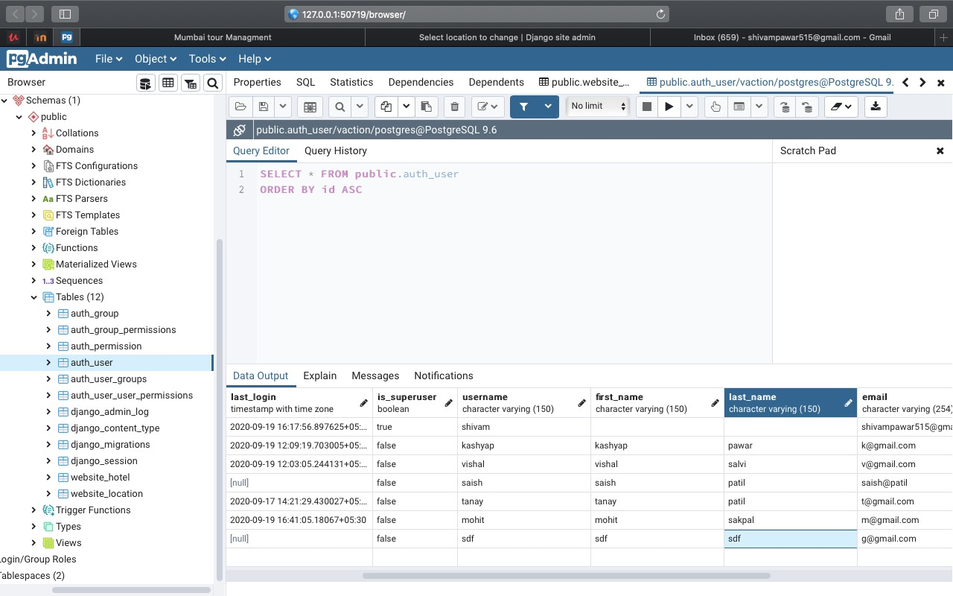

**Conclusion**: Thus, we implement web application by using Django Framework also learn the authentication and database connectivity by using PostgreSQL database in Django framework.